
Data Flow Diagram

Date | 15 March 2026
Team ID
Project Name | Smart Lender
Maximum Marks | 2 Marks

Data Flow Diagram :

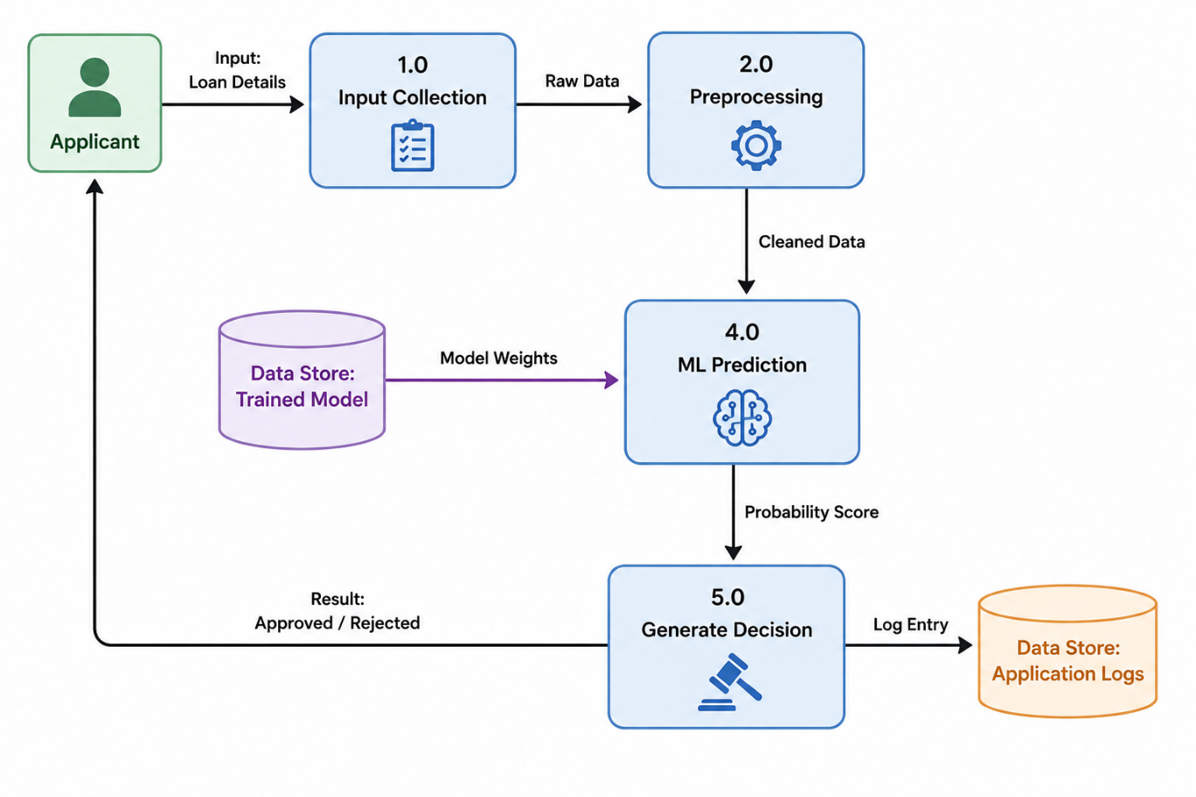



Symbol | Name | Description
Oval / Rounded shape | External Entity | A person, organization, or system outside the project that sends or receives data (e.g., Customer, Payment Gateway).
Rectangle with numbered header | Process | An activity that transforms incoming data into outgoing data (e.g., Validate Request, Process Order).
Rectangle (solid fill, no number) | Data Store | A place where data is held for later use (e.g., Customer Database, Inventory).
Labeled arrow | Data Flow | The movement of data between entities, processes, and data stores, labeled with what data is being passed.


DFD Symbol Legend:

